THE CULTURE LANDSCAPE FOR THE TABLETS

First,an my opinion,this is the broad lanscape:

Here you see how much close is the origin of greek At the origin point,wereProto-Aegean/Vinca-Turdas cultures. The point is very close to the origin of PIE and Anatolian languages.This could be noticed in the Anatolian-Eastern characteristics wich could be traced in Mycenaean and much more in Minoan languages.

http://rsos.royalsocietypublishing.org/content/royopensci/3/1/150645/F2.large.jpg

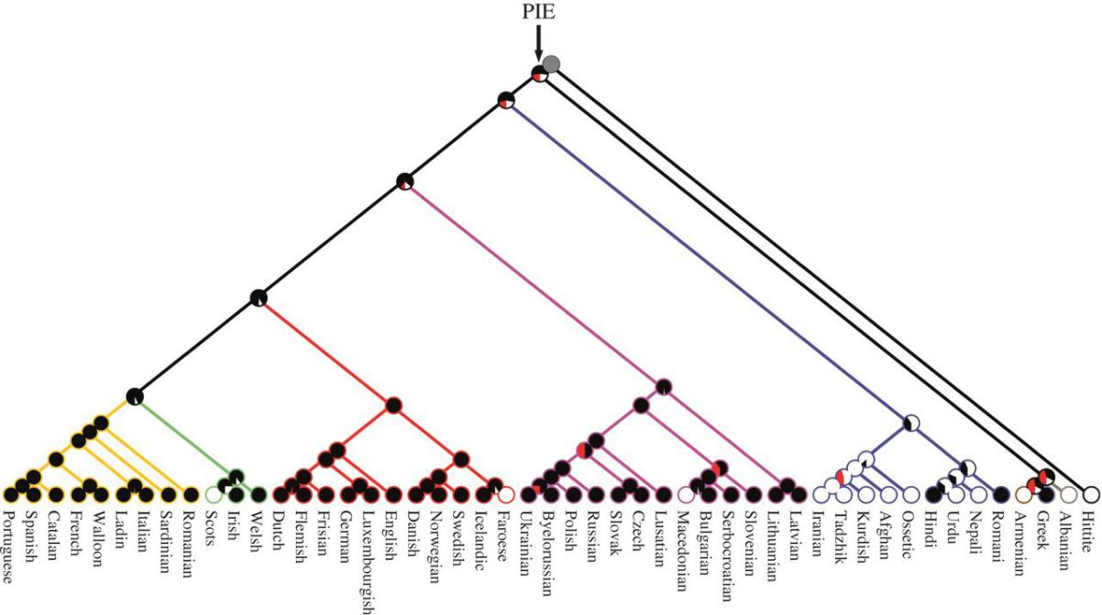

Going even more back in time,

https://upload.wikimedia.org/wikipedia/commons/thumb/0/03/Nostratic_tree.svg/330px-Nostratic_tree.svg.png

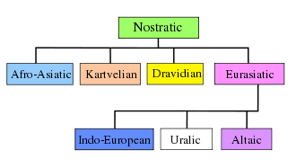
We see that there is a common point in wich diverged Dravidian and PIE.
Before this point possible was:
https://wikivisually.com/wiki/Proto-Euphratean_language
Proto-Euphratean is a hypothetical unclassified language or languages which was considered by some Assyriologists (for example Samuel Noah Kramer), to be the substratum language of the people that introduced farming into Southern Iraq in the Early Ubaid period (5300-4700 BC).
Dyakonov and Ardzinba identified these hypothetical languages with the Samarran culture.[1]
Benno Landsberger and other Assyriologists argued that by examining the structure of Sumerian names of occupations, as well as toponyms and hydronyms, one can suggest that there was once an earlier group of people in the region who spoke an entirely different language, often referred to as Proto-Euphratean. Terms for "farmer", "smith", "carpenter", and "date" (as in the fruit), also do not appear to have a Sumerian or Semitic origin.
Linguists coined a different term, "banana languages," proposed by Igor Dyakonov and Vladislav Ardzinba, based on a characteristic feature of multiple personal names attested in Sumerian texts, namely reduplication of syllables (like in the word banana): Inanna, Zababa, Chuwawa, Bunene etc. The same feature was attested in some other unclassified languages, including Minoan, the same feature is allegedly attested by several names of Hyksos rulers: although Hyksos tribes were Semitic, some of their names, like Bnon, Apophis, etc. were apparently non-Semitic by origin.[2]
Rubio challenged the substratum hypothesis, arguing that there is evidence of borrowing from more than one language, this theory is now predominant in the field (Piotr Michalowski, Gerd Steiner, etc.).
A related proposal by Gordon Whittaker[3] is that the language of the proto-literary texts from the Late Uruk period (c. 3350–3100 BC) is an early Indo-European language which he terms "Euphratic".

This the point is that of proto-elamite=ancient sumero tamil=sumerian.After that point diverged indic languages and Proto-Indo European-ones.

Image; http://realhistoryww.com/world_history/ancient/Images_Indus/chart.JPG

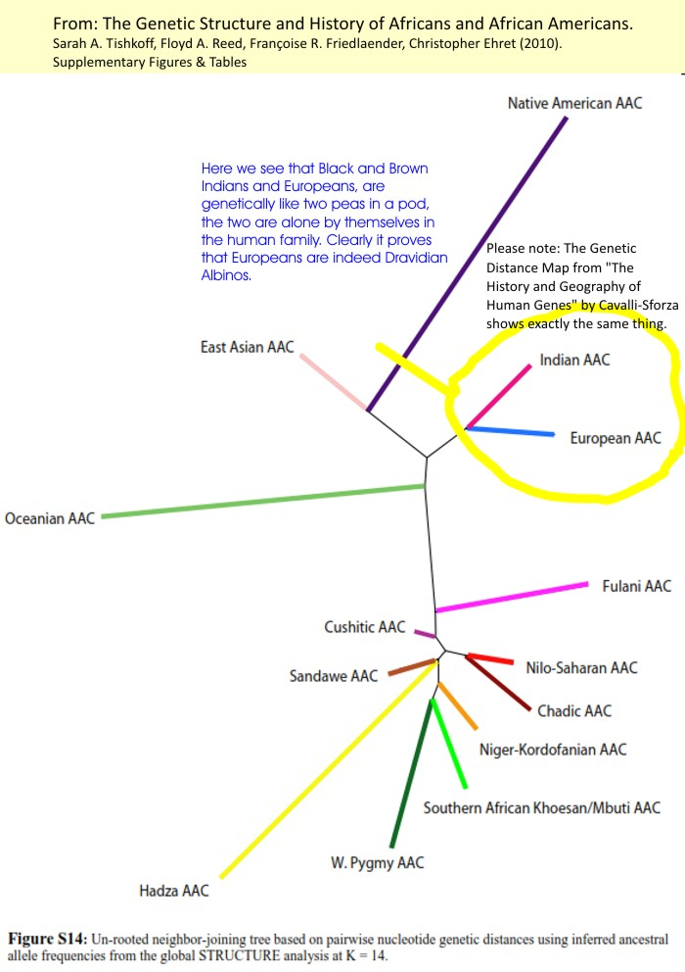

That’s why many Indo-European languages keep strong sanskrit traces.
In a way or another in neolithic-bronze ages were twoo different coming waves, and there was a population>cultural influx toward Europe from East.From PIE Indo-Hittite branch, Anatolian one remained in Anatolia.
https://ro.pinterest.com/pin/ASKBirGnDwE-lbkoK56oVnZb7_LUHpzam35w6kZVPJzPtzutUX8goA8/

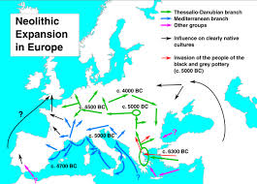
So, in any circumstances,the supposed writings could not depass the limits:
-not older than proto-elamite=ancient sumero-tamil=sumerian 3200 B.C.
-Not younger (but same-how possible only for the round tablet)than 2200-1450 B.C. wich is the time between cretan hierogliphic,linear A and linear B.

ttps://www.google.ro/imgres?imgurl=http%3A%2F%2Fimages.slideplayer.com%2F22%2F6488709%2Fslides%2Fslide_4.jpg&imgrefurl=http%3A%2F%2Fslideplayer.com%2Fslide%2F6488709%2F&docid=D0Bos81UUoT5IM&tbnid=p9nQNs-Ub7HWyM%3A&vet=10ahUKEwj44My9kNPZAhVKa1AKHVmbD0YQMwhlKB0wHQ..i&w=960&h=720&bih=662&biw=1366&q=cycladic%20minoan%20mycenaean%20%20map&ved=0ahUKEwj44My9kNPZAhVKa1AKHVmbD0YQMwhlKB0wHQ&iact=mrc&uact=8

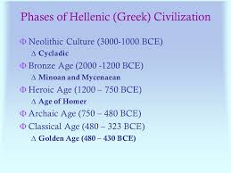
Beside I am not confident about supposed age of the tablets 5.200 B.C. wich is not at all possible in my opinion.(Romanian schollars gave this age of the tablets as beeing the same !? of some bones found near-by.)
https://encrypted-tbn0.gstatic.com/images?q=tbn:ANd9GcR_vsc7SH3mmcya8yaZsPyBJM-uIppTKybAoO5VyjiOTnwL-kIDzQ

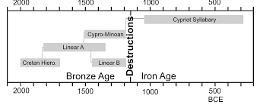
http://www.anistor.gr/english/enback/2016_2e_Anistoriton.pdf
“Between 3000/2600 and 1450, the period of the birth and development of Cretan Hieroglyphic and Linear A, […] the introduction of a language known to us from elsewhere is unlikely.”

Thus in my opinion the expected language is or close to an early Indo-European language which he terms "Euphratic".

